Logging in to the Canadian HR folder on a US laptop:

You should be supplied a Canada Windows account and password.

To test, please map a network drive.

To map a drive, open File Explorer and right click This PC to make the selection as shown.

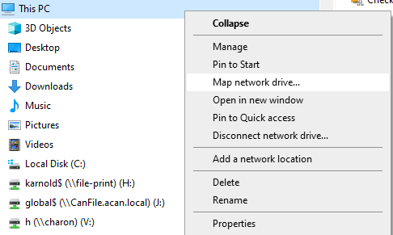

Map a network drive to \\172.29.210.22\hr$ as shown below.

Any drive letter you have available will be fine.

Choose to “Connect using Different Credentials” and use **the account provided in the format: AGACA\xxxxxxxxxx**

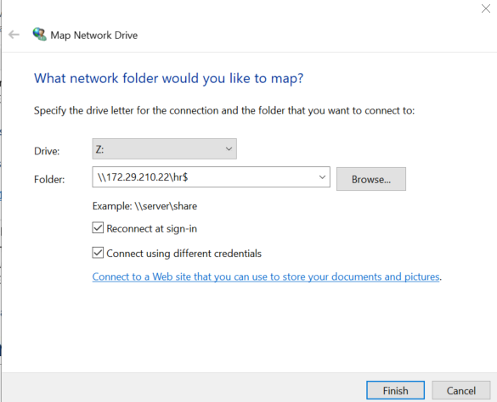

Enter the supplied name and password in the prompt to make a connection:

**AGACA\xxxxxxxxxx**

(the password supplied)